Advanced SQL
Q1. What is a Common Table Expression (CTE), and how does it improve SQL query readability?
Solution:
A Common Table Expression (CTE) is a temporary result set that you can reference within a SELECT, INSERT, UPDATE, or DELETE statement. It is defined using the WITH clause.
It improves readability by:
Simplifying Complex Queries: It breaks down large, nested queries into smaller, logical blocks.
Reducing Repetition: You can define a logic once and reference it multiple times in the main query.
Self-Documentation: By giving the CTE a descriptive name, the intent of that specific code block becomes clear.

Q2. Why are some views updatable while others are read-only? Explain with an example.
Solution:
A view is updatable if it maps directly to rows in a single base table without ambiguity. It is read-only if it contains complex logic that prevents the database from knowing exactly which source row to modify.
Example: A view created using SELECT ProductID, Price FROM Products is updatable. However, a view that uses SUM(Price) or GROUP BY Category is read-only because one row in the view represents multiple rows in the table; the system wouldn't know which specific product's price to change.
Q3. What advantages do stored procedures offer compared to writing raw SQL queries repeatedly?
Solution:
Performance: They are compiled once and stored, making execution faster than raw SQL.
Security: Users can be granted permission to run a procedure without having direct access to the underlying tables.
Maintainability: If business logic changes, you only update the procedure in one place rather than searching through application code.
Network Efficiency: Only the procedure name and parameters are sent over the network, reducing traffic.
Q4. What is the purpose of triggers in a database? Mention one use case where a trigger is essential.
Solution:
The purpose of a trigger is to automatically execute a piece of code in response to a specific event (like INSERT, UPDATE, or DELETE) on a table.
Essential Use Case: Audit Logging. A trigger is essential for automatically recording who changed a record and when, ensuring a permanent history of changes that cannot be bypassed by manual entries.
Q5. Explain the need for data modelling and normalization when designing a database.
Solution:
Data modelling acts as a blueprint for the database structure. Normalization is required to:
Eliminate Redundancy: Prevents storing the same data in multiple places.
Ensure Data Integrity: Ensures that updates or deletions don't leave the database in an inconsistent state.
Optimize Performance: Organizes data so that queries can join tables and retrieve information efficiently.
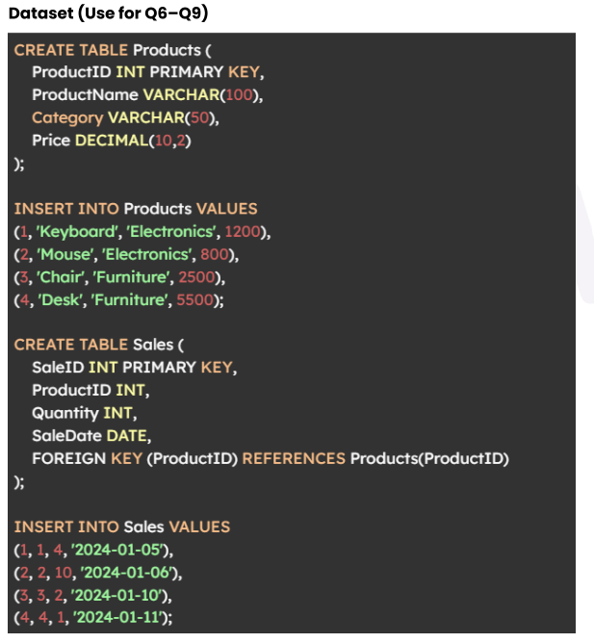
Q6. Write a CTE to calculate the total revenue for each product (Revenues = Price × Quantity), and return only products where revenue > 3000
Solution:
WITH ProductRevenue AS (
SELECT
p.ProductName,
(p.Price * s.Quantity) AS TotalRevenue
FROM Products p
JOIN Sales s ON p.ProductID = s.ProductID
)
SELECT *
FROM ProductRevenue
WHERE TotalRevenue > 3000;
Q7. Create a view named vw_CategorySummary that shows: Category, TotalProducts, AveragePrice.
Solution:
CREATE VIEW vw_CategorySummary AS
SELECT
Category,
COUNT(ProductID) AS TotalProducts,
AVG(Price) AS AveragePrice
FROM Products
GROUP BY Category;
Q8. Create an updatable view containing ProductID, ProductName, and Price. Then update the price of ProductID = 1 using the view.
Solution:
-- Create the updatable view
CREATE VIEW vw_ProductDetails AS
SELECT ProductID, ProductName, Price
FROM Products;

-- Update using the view
UPDATE vw_ProductDetails
SET Price = 1300
WHERE ProductID = 1;

Q9. Create a stored procedure that accepts a category name and returns all products belonging to that category.
Solution:
CREATE PROCEDURE GetProductsByCategory
@CategoryName VARCHAR(50)
AS
BEGIN
SELECT *
FROM Products
WHERE Category = @CategoryName;
END;
Q10. Create an AFTER DELETE trigger on the Products table that archives deleted product rows into a new table ProductArchive. The archive should store ProductID, ProductName, Category, Price, and DeletedAt timestamp.
Solution:

CREATE TRIGGER trg_ArchiveDeletedProduct
AFTER DELETE ON Products
FOR EACH ROW
BEGIN
INSERT INTO ProductArchive (ProductID, ProductName, Category, Price, DeletedAt)
VALUES (OLD.ProductID, OLD.ProductName, OLD.Category, OLD.Price, CURRENT_TIMESTAMP);
END;

